Library Circulation Proxy Form

Faculty and proxy should obtain their new Action Card before completion of Proxy Form.

I, ______________________________________________, hereby request that my ID, as pictured below, be

used to check out books in my name by ______________________________________________, whose ID is also pictured. I understand that I am assuming responsibility for returning, in good condition, the materials checked out in my name using this proxy. Please honor this request until____________________________________. (specific date is required, or this form is not valid)

Signed__________________________________________________

Dept/Position____________________________________________

Date___________________________________________________

My ID CWID #__________________________

Copy ID card here

Proxy ID CWID #_________________________

Copy ID card here

It is the proxy patron’s responsibility to advise circulation staff that items are being checked out by PROXY
Copies to: Circulation Services University Libraries, Requesting Faculty/Staff, and Proxy
libraries.ua.edu
How to Upload Screenshot of Action Card from Phone Wallet (Apple or Android)
- Open your phone’s default wallet to display all your digital cards.
Apple Wallet 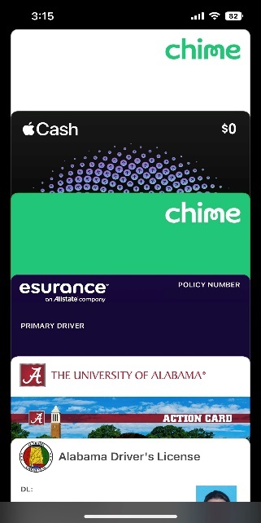 Android 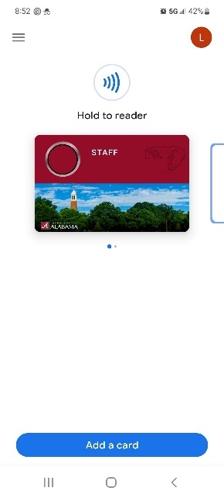 Google Pay
- Select your action card so that it is the main card showing on your screen.
Apple Wallet 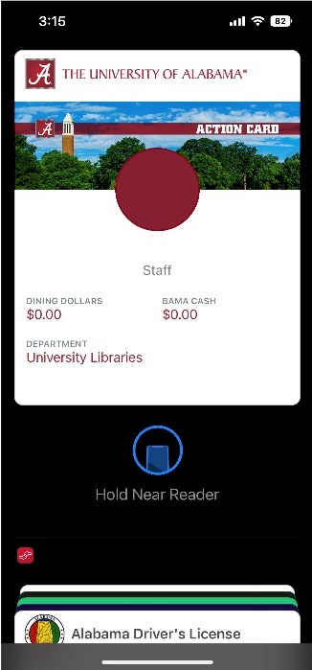 Android 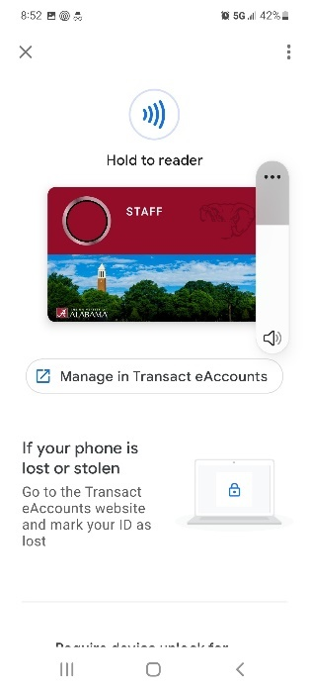 Google Pay
- Take a screenshot by following your phone’s settings (usually pressing the volume down and the lock button at the same time).
- Crop the image so only the action card is visible.
Apple Wallet 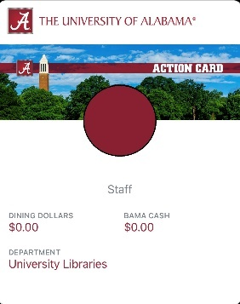 Android Google Pay
- Email the image to yourself and then download the file to your computer.
- Open the proxy form and insert the photo into the appropriate spot. Easier to use Adobe Acrobat.

